CHAPTER 6
Elasticity: The Responsiveness of Demand and Supply
- Chapter Summary
- Learning Objectives
- Chapter Outline
Teaching Tips/Topics for Discussion
- Solved Problems
- Solutions to Review Questions and Problems and Applications

1. Chapter Summary
The price elasticity of demand equals the percentage change in quantity demanded of a product divided by the percentage change in the product’s price. If the quantity demanded is responsive to a change in price, the price elasticity of demand will be greater than 1 in absolute value; demand is elastic. If the quantity demanded is not very responsive to a change in price, the elasticity of demand will be less than 1 in absolute value; demand is inelastic. Demand is unit-elastic when the percentage change in quantity demanded equals the percentage change in price and the absolute value of the price elasticity of demand equals 1.
The midpoint elasticity formula results in a unique value when calculating the elasticity of demand. A demand curve drawn as a vertical line represents a perfectly inelastic demand curve. A perfectly elastic demand curve is drawn as a horizontal line.
There are five main determinants of the price elasticity of demand for a product. The most important determinant is the availability of close substitutes for the product. The more substitutes for a product, the greater the price elasticity of demand. The passage of time is another determinant of elasticity; demand becomes more elastic as more time passes. Luxuries versus necessities is another determinant. The demand curve for a luxury is more elastic than the demand curve for a necessity. The definition of the market is also a determinant of elasticity. A narrow definition of a market will have a more elastic demand than a broad definition for the same market. The smaller the share of the good or service in the consumer’s budget, the more inelastic the demand for that good or service will be.
Total revenue equals price per unit multiplied by the number of units sold. When demand is inelastic, price and total revenue move together: if price increases, total revenue increases, and when price decreases, total revenue decreases. When demand is elastic, price and total revenue change in the opposite direction: if price increases, total revenue decreases, and when price decreases, total revenue increases.
Elasticity has a different value at each point along most demand curves; the absolute value of the elasticity will be relatively great at high prices and will decline as price is lowered.
Two other demand elasticities measure the responsiveness of one economic variable to another economic variable. The cross price elasticity equals the percentage change in the quantity demanded of one good divided by the percentage change in the price of another good. The sign of the cross price elasticity is positive for two substitute goods, negative for two complements, and zero for two unrelated goods. The income elasticity equals the percentage change in quantity demanded for a good or service divided by the percentage change in income. The sign of the income elasticity will be positive for a normal good and negative for an inferior good. For normal goods which are necessities, the income elasticity will be positive but less than one. For normal goods which are luxuries, the income elasticity will be greater than one.
The price elasticity of supply equals the percentage change in quantity supplied divided by the percentage change in price. The price elasticity of supply will always be a positive number (or will equal zero if supply is perfectly inelastic). In general, the elasticity will be greater the longer the period of time firms have to make this adjustment.

2. Learning Objectives

Students should be able to:
- Define the price elasticity of demand and understand how to calculate it.
- Understand the determinants of the price elasticity of demand.
- Understand the relationship between the price elasticity of demand and total revenue.
- Define the cross-price elasticity of demand and the income elasticity of demand, and understand their main determinants and how they are calculated.
- Use price elasticity and income elasticity to analyze economic issues.
- Define the price elasticity of supply, and understand its main determinants and how it is calculated.

3. Chapter Outline
Do People Care About the Price of Books?
1. The experience of the book publishing industry demonstrates the importance of estimating the demand for a product and setting its price. These decisions have a significant impact on the firm’s revenues.
►Teaching tips: At the end of this chapter, An Inside Look analyzes the fortunes of online technology firms Microsoft and Amazon.com. Amazon.com, along with other online retailers, has become an increasingly important bookseller. The article from USA Today and the questions that follow, as well as the introduction to the chapter, can be used as the basis for classroom discussion.
One may ask students related questions regarding the increased popularity of online shopping. Why do many consumers buy books online rather than from traditional bookstores? (Online sellers have large inventories, so consumers are more likely to find the books they want online. Online shopping can be done from one’s home or workplace; purchases can be shipped to either location.) What goods are more likely to be purchased from stores and shopping malls rather than from online retailers? (Many consumers prefer to see, touch, and try on some items before buying. Examples include clothing and food products.)
The Price Elasticity of Demand and Its Measurement
1. The price elasticity of demand is the responsiveness of the quantity demanded to a change in price, measured by dividing the percentage change in the quantity demanded of a product by the percentage change in the product’s price.
- All elasticity formulas may be stated as fractions or ratios of two percentage change values.
- Because of the law of demand, the sign of this elasticity is always negative. To simplify interpretation, the absolute values of price elasticity are taken so that the negative sign is ignored.
- Elastic demand occurs when the percentage change in quantity demanded is greater than the percentage change in price, so the price elasticity is greater than 1 in absolute value.
- Inelastic demand occurs when the percentage change in quantity demanded is less than the percentage change in price, so the price elasticity is less than 1 in absolute value.
- Unit-elastic demand occurs when the percentage change in quantity demanded is equal to the percentage change in price, so the price elasticity is equal to 1 in absolute value.
2. Because the value of the price elasticity of demand is different for each price and quantity combination, the midpoint formula is used to calculate elasticity values. In this formula, the change in quantity that results from a price change (Q₂ – Q₁) or ΔQ is divided by the average of these quantities to calculate the percentage change in quantity demanded. The percentage change in price is calculated by dividing the change in price (P₂ – P₁) or ΔP by the average of these prices. The elasticity values obtained with the midpoint formula are the same for either a price increase or price decrease between P₂ and P₁.
►Teaching tips: Student understanding of elasticity may be increased by rewriting the formula.
E(lasticity) = 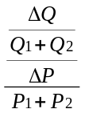
=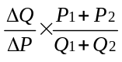
Since the slope of a linear, or straight line, demand curve is constant and can be written as Δ P/Δ Q, the elasticity formula can be written as:
E = (1/slope) 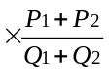
This formula illustrates several important points. (1) Elasticity is clearly not equal to the slope of a linear demand curve. (2) Although a linear demand curve has a constant slope, the elasticity will be different for every segment of the demand curve. (3) Since relatively high values for price are associated with relatively low values of quantity demanded (and vice versa), the absolute values for elasticity will be high at high prices (demand is elastic) and relatively low at low prices (demand is inelastic). This can be easily shown by substituting in price and quantity values for a given demand curve into the rewritten formula and observing the change in the ratio of (P₁ + P₂) to (Q₁ + Q₂).
3. Two extreme cases of elasticity may be observed.
- Perfectly inelastic demand occurs when a change in price results in no change in quantity demanded.
- Perfectly elastic demand occurs when a change in price results in an infinite change in quantity demanded.
►Teaching tips: After illustrating a perfectly inelastic demand curve, one may ask students to suggest examples. They may mention products such as cigarettes or gasoline that have relatively inelastic, but not perfectly inelastic, demands. Ask if the quantity demanded of the products they suggest would not change if the price were not only higher but lower as well. Even students who claim consumers would not buy less gasoline if the price rose won’t argue that no more gasoline would be purchased at lower prices. This discussion will help students understand that there are no good substitutes for a product with a perfectly inelastic demand. In addition to the textbook’s example of insulin for a diabetic, other examples include the demand for an organ transplant operation or an antidote for deadly snake bite or disease.
One should consider skipping lightly over classroom discussion of perfectly elastic demand. It should be sufficient to make a brief reference to perfect competition, a topic covered in another chapter of the text.
What Determines the Price Elasticity of Demand for a Product?
1. There are five key determinants of the price elasticity of demand.
- The availability of close substitutes.
- The passage of time.
- Whether the product is a necessity or luxury.
- The definition of the market.
- The share of the consumer’s budget accounted for by purchases of the product.
►Teaching tips: It is useful at this point to emphasize two important points. First, each of the five determinants should be considered separately from the others. A product that consumes a small part of a consumer’s budget (this suggests demand would be relatively inelastic) may have several good substitutes (this suggests demand would be relatively elastic). Second, changes in the market price of any product will result in different values for price elasticity. Estimates of the price elasticity of demand, such as those cited in the text for breakfast cereals, utilize market prices for products at a particular time. Different market prices would result in different elasticity estimates.
The Relationship Between Price Elasticity and Total Revenue
1. Changes in price and quantity demanded result in changes in the total revenue received by firms.
- Total revenue is the total amount of funds received by the seller of a good or service, calculated by multiplying price per unit by the number of units sold.
- Changes in total revenue are related to the price elasticity of demand.
- If demand is elastic, changes in price (increase or decrease) will result in changes in total revenue in the opposite direction.
- If demand is inelastic, changes in price will result in changes in total revenue in the same direction as the change in price.
- When demand is unit-elastic, a change in price (increase or decrease) results in no change in total revenue.
►Teaching tips: The relationship between elasticity and changes in revenue is very important. Students often have difficulty understanding this relationship without significant class discussion and/or work done outside of class. One may assign Solved Problem 6-2 for review and #11 of the Problems and Applications for homework for this purpose.
Other Demand Elasticities
1. The cross price elasticity of demand (CPE) is the percentage change in the quantity demanded of one good divided by the percentage change in price of the other good.
- For two substitute goods, the CPE > 0.
- For two complements, the CPE < 0.
- For two unrelated goods, the CPE = 0.
2. The income elasticity of demand (IE) of demand is a measure of the responsiveness of quantity demanded to changes in income, measured by the percentage change in quantity demanded divided by the percentage change in income.
- For normal goods, the IE > 0.
1). For necessities, 0 < IE < 1.
2). For luxuries, the IE > 1.
- For inferior goods, the IE < 0.
►Teaching tips: Many students confuse one type of elasticity with another. Making the Connection 6-3 lists and analyzes several different elasticity estimates. Consider basing classroom discussion or a homework assignment around this information.
One can test student understanding of elasticity by assigning the following problem: Assume that the price elasticity of demand for good X is (-) 2.5. Is good X a normal good? (Answer: One cannot determine whether X is normal or inferior by knowing its price elasticity. One must have knowledge of the income elasticity of demand for good X).
Using Elasticity to Analyze the Disappearing Family Farm
1. The demand for many agricultural commodities (for example, wheat) is price inelastic while the income elasticity for these commodities is low (positive but less than one).
2. Technological change has caused large increases in the supply of agricultural commodities over time.
- Because of the low income elasticity of demand for these commodities, demand has increased much less than supply.
- There has been a reduction in the relative price of many agricultural commodities.
- Fewer and fewer farmers are needed to produce agricultural commodities.
►Teaching tips: This is an excellent example of how knowledge of elasticity explains an important economic and social issue. Classroom time spent reviewing Figure 6-4 will be worth the effort. Alternatively, students can be advised to review the graph in Figure 6-4 and the explanation in the text on their own.
Solved Problem 6-3 (Using Price Elasticity to Analyze the Drug Problem) is another excellent application of elasticity to an economic issue. Instructors should consider assigning this and the related end of chapter problems 3 and 4 for a homework assignment. This material can also be the basis for examination problems. Student understanding of elasticity is enhanced by teaching the concept through application to real issues.
The Price Elasticity of Supply
1. The price elasticity of supply is the responsiveness of the quantity supplied to a price change, measured by dividing the percentage change in the quantity supplied of a product by the percentage change in the product’s price.
- Because of the law of supply, this elasticity normally will have a positive numerical value.
- The longer the time period firms have to respond to a price change, the greater the elasticity of supply.
►Teaching tips: By the time students first encounter this topic, they will have spent much time on several various types of elasticity. Although supply elasticity is important, the opportunity cost of spending classroom time on the topic cannot be ignored. After an explanation of supply, elasticity instructors should consider assigning Making the Connection 6-4 as an “on your own” reading.

4. Solved Problems
Chapter 6 of the textbook includes 3 Solved Problems that support Learning Objectives 1 (Define the price elasticity of demand and understand how to calculate it), 3 (Understand the relationship between the price elasticity of demand and total revenue) and 5 (Use price elasticity and income elasticity to analyze economic issues). The following are additional Solved Problems that support the other learning objectives from this chapter.

Solved Problem 6-4 Supports Learning Objective 2: Understand the determinants of the price elasticity of demand.

Hailing a Cab in the Big Apple
In New York City, the government sets the fares that taxi drivers can charge. In early 2002, some taxi drivers were upset when Mayor Michael Bloomberg proposed a fare increase. One driver was quoted as saying, “I get scared that we will start to lose passengers if rates go up and not gain a cent.”
- What was the driver assuming about the price elasticity of demand for taxi rides?
- Which of the five determinants of elasticity would be the most important determinant of the price elasticity of demand for taxi rides in New York City?

Solving the Problem:
Step 1: Review the chapter material. This problem refers to the determinants of the price elasticity of demand, so you may want to review the section What Determines the Price Elasticity of Demand for a Product? that begins on page 172 of the textbook.
Step 2: Interpret the taxi cab driver’s assumption regarding the price elasticity of demand for taxi rides. The driver asserted that if the price of a cab ride rose, the quantity demanded of rides would fall (“…we will start to lose passengers…”) but that the revenue he would receive from fares would be constant (“…we will…not gain a cent”). Therefore, the driver is assuming demand for cab rides is unit-elastic.
Step 3: Determine which of the determinants of the elasticity of taxi cab rides in New York City is the most important. The most important determinant of the price elasticity of demand is typically the availability of substitutes. On most occasions, consumers can choose to travel by subway, bus for hire or taxi. Some consumers may drive their own automobiles. For many residents and tourists, the latter option is impractical or more expensive than the others because of the difficulty and expense associated with finding parking spaces.

Source: Jayson Blair, “Some Taxi Drivers Say a Fare Increase Would Be Bad for Business,” New York Times, February 24, 2002.

Solved Problem 6-5: Supports Learning Objective 4: Define the cross-price elasticity of demand and the income elasticity of demand, and understand their determinants and how they are calculated.

A Subway Fare Increase and an Economic Boom Affect the Taxi Business
Assume that two separate events affect the market for taxi rides in New York City:
- There is a 20 percent increase in New York subway fares. As a result, taxi cab rides increase 5 percent.
- An economic expansion causes a 5 percent increase in the incomes of tourists visiting New York City. Taxi cab rides increase 2 percent.
Describe the cross-price and income elasticity formulas and use these formulas to determine the values of these elasticities for taxi cab rides.

Solving the Problem:
Step 1: Review the chapter material. Since this problem refers to the determinants of the cross-price elasticity and income elasticity of demand, you may want to review the section Other Demand Elasticities that begins on page 178 of the textbook.
Step 2: State the cross-price elasticity formula and determine the value of this elasticity for taxi cabs rides. The cross-price elasticity formula is:
Percentage change in quantity demanded of one good
Percentage change in price of another good

Since a 20 percent increase in subway fares raised the quantity demanded of taxi rides by 5 percent, the value of the cross-price elasticity is:
5 percent = 0.25 . Subway and taxi rides are substitutes, so the elasticity is positive.
20 percent

Step 3: State the income elasticity formula and determine the value of this elasticity for taxi rides. The income elasticity is:
Percentage change in quantity demanded of one good
Percentage change in income

Since a 5 percent increase in income led to a 2 percent increase in taxi rides, the value of the income elasticity is:
2 percent = 0.4 .
5 percent

The elasticity is positive but less than 1. Therefore, a taxi ride is a normal good
and a necessity.
Solved Problem 6-6
Supports Learning Objective 6: Define the price elasticity of supply, and understand its main determinants and how it is calculated.

The Supply of Medallions and the Supply Taxis
The number of taxicab licenses in New York City has been limited since 1937, when there were fewer than 14,000 outstanding licenses. These licenses are also called medallions. As some cab owners allowed their licenses to expire, the number of licenses fell to the current number of 11,787. The Taxi and Limousine Commission was created by the New York City Council in 1971 to regulate taxi and livery service. Despite the great demand for taxi service, with over 220 million passengers a year, no new cabs are allowed to operate without one of the existing medallions. License holders are allowed to sell their medallions. In 2004, the average price paid for a medallion was over $275,000.

- Use the price elasticity of supply formula to calculate the elasticity of supply for taxicab medallions in New York City.
- Assume that the Taxi and Limousine Commission doubles the number of available medallions. Describe the likely impact on the quantity supplied and elasticity of supply of taxicabs.
Step 1: Review the chapter material. Since this problem refers to the determinants of the elasticity of supply, you may want to review the section The Price Elasticity of Supply that begins on page 183 of the textbook.
Step 2: State the price elasticity of supply formula and determine the value of this elasticity for taxi cab medallions. The price elasticity of supply formula is:
Percentage change in quantity supplied
Percentage change in price

Since the quantity supplied of medallions is fixed, the percentage change in quantity supplied is zero, the value of the elasticity of supply is zero, and the supply curve is vertical at the existing quantity of 11,787 medallions, no matter how much the price of medallions changes.
Step 3: Determine the impact of a doubling of medallions. The high price of existing medallions suggests that current, and possibly new, cab companies would bid for the new medallions. But the number of cabs in service would not rise immediately since companies would have to acquire new vehicles and hire and train new drivers. As the market period lengthens (from one day to one month, to one year, etc.), the quantity supplied of cabs in service and the elasticity of supply of taxi cabs would increase; the supply curve would become increasingly flatter.

Sources: The New York City Taxicab Fact Book (3rd ed.) by Bruce Schaller. http://schallerconsult.taxi/taxifb94.htl
New York City Taxi & Limousine Commission Medallion Sale Information
http://wwwnyc.gov/html/tlc/medallion/html/home/home.shtml

5. Solutions to Review Questions and Problems and Applications

Answers to Thinking Critically Questions

1. As the price gets higher and higher, the price elasticity of demand generally gets higher, as shown in Figure 6-3. Thus, at a high enough price, the demand for books on Amazon.com will become elastic and revenue will fall.

2. As more competitors go online, there will be more close substitutes available for Amazon.com’s products. This will increase the price elasticity of demand for its products.

Answers to Review Questions

1. Price elasticity of demand = (percentage change in quantity demanded)/(percentage change in price). It isn’t measured by the slope of the demand curve because the slope depends arbitrarily on what units you are using. Slope will change by a factor of 100 if you use cents instead of dollars, for example.

2. The price elasticity = (percentage change in quantity demanded)/(percentage change in price) = –25%/10% = –2.5. This is elastic.

3. In calculating the percentage change in price and quantity, the midpoint formula divides by the average of the starting and ending values.
Midpoint Formula:

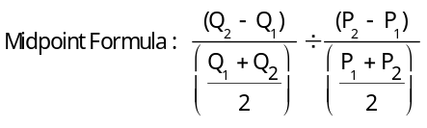

Percentage changes can also be calculated by using the starting or ending value without averaging, but this gives different results depending on whether the starting or ending value is used.

4. If demand is inelastic, an increase in price will increase revenue, because the price will rise at a greater rate than sales decline.

5. The demand for most agricultural goods is inelastic. This is probably because people already have about enough to eat, so they won’t increase purchases much if the price falls.

6. The most important determinant of the price elasticity of demand is usually the availability of substitutes for the product. If there are good substitutes, elasticity will be high because people can switch away to another good as the product’s price rises. Other factors determining the price elasticity of demand for a product include the passage of time, whether the good is a necessity or a luxury, how narrowly the market for the good is defined, and the share of the good in the consumer’s budget.

7. A perfectly inelastic demand curve is shown by a vertical line, as shown at the bottom of Table 6-1. Such a good will have no substitutes; for example, a life-saving drug.

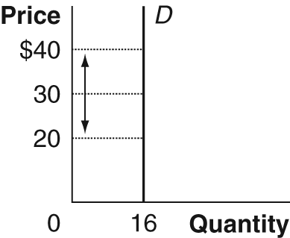

8. Cross-price elasticity of demand equals the percentage change in quantity demanded of one good divided by the percentage change in the price of another good. If the cross-price elasticity is negative, the goods are complements; if it is positive, they are substitutes.

9. Income elasticity equals the percentage change in the quantity demanded divided by the percentage change in income. If the income elasticity is greater than zero, the good is normal; if it is less than zero, the good is inferior. Goods with income elasticities between zero and one are often called necessities; those with income elasticities greater than one are often called luxuries.

10. Price elasticity of supply = (percentage change in quantity supplied)/(percentage change in price). In this case, the elasticity of supply = 9%/10% = 0.9. This is slightly inelastic. The dividing point between elastic and inelastic is 1.0.

Answers to End-of-Chapter Problems and Applications

1a: 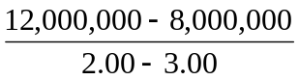 = –4,000,000.

b. 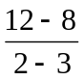 = –4.

c. 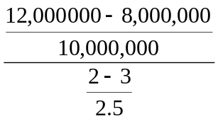 = 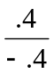 = –1.0,
or, following the convention of reporting elasticities as positive numbers, the price elasticity is 1.0. Notice that the numbers calculated in a. and b. are significantly different.

2. Elasticity = (percentage change in quantity)/(percentage change in price) = –3%/4% = –0.75. Because price rises and demand is price inelastic, revenue received by suppliers has increased.

3a. (Percentage change in price) x (price elasticity of demand) = percentage change in quantity: 50% x -0.25 = –12.5%. So, the quantity of cigarettes demanded should decline 12.5% from its current level of 480 billion per year. 12.5% of 480 billion is 60 billion.
b. If the demand for cigarettes is elastic, the price increase resulting from a tax increase will cause a larger decline in the quantity demanded.

4. (Percentage change in price) x (price elasticity of demand) = percentage change in quantity. 20% x –0.28 = –5.6%, so the reduction in quantity demanded will be 5.6%.

5a. Soft drinks and canned soup are elastically demanded; cheese and toothpaste are inelastically demanded. Cheese and toothpaste probably have fewer substitutes than soft drinks and canned soup.
b. Soft drinks: 31.8% decline in quantity demanded
Canned soup: 16.2% decline in quantity demanded
Cheese: 7.2% decline in quantity demanded
Toothpaste: 4.5% decline in quantity demanded

6a.

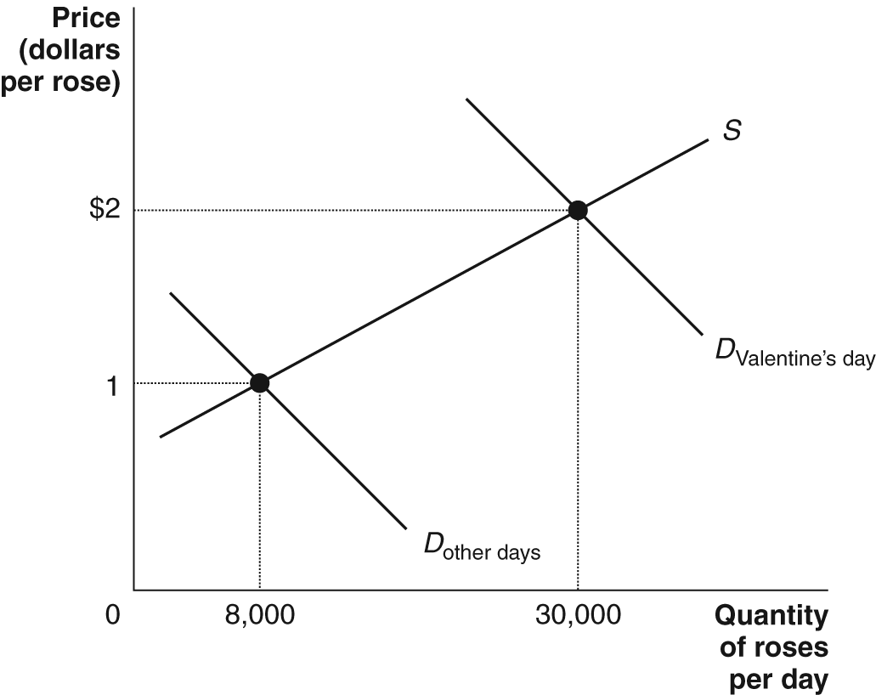

6b. Based on this information, we don’t know much at all about the price elasticity of demand for roses. The demand curve has shifted, so the rise in the quantity of roses demanded is not caused by the rise in their price – and we can’t calculate the demand elasticity. We have a movement along the supply curve, so we can calculate the price elasticity of supply for roses.

The supply elasticity = (percentage change in quantity supplied)/(percentage change in price) = 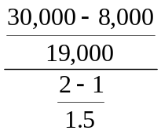 = 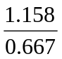 = 1.74.

The fact that the elasticity doesn’t have a negative sign is a reminder that this isn’t the price elasticity of demand – which would be negative.

7. Price inelastic, since the percentage change in price is much larger than the percentage change in quantity demanded.

8a. Along D₁ between points A and C, the price elasticity of demand is

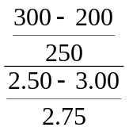 = 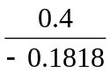 = –2.2.

Along D₂ between points A and B, the elasticity of demand is

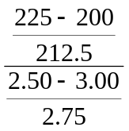 = 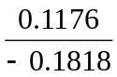 = –0.65.

Because the quantity response is much larger to the same price cut, demand curve D₁ is much more elastic.

8b. Along D₁, revenue climbs from $3 x 200 = $600 to $2.50 x 300 = $750. Revenue rises as the price is cut, because this demand curve is elastic. Along D₂, revenue falls from $600 to $2.50 x 225 = $562.50. Revenue falls as the price is cut, because D₂ is inelastic.
9. It must be unit elastic – revenue is unchanged, so the percentage changes in the price and quantity demand must be exactly the same. If Continental charges the low fare, it will be worse off, because the additional passengers will increase Continental’s costs, without increasing its revenues, thereby reducing its profits. The more passengers, the more fuel that is burned, the more peanuts and soft drinks that have to be served, and so on.

10. Percentage change in quantity = 1000/500,500 = .001998. Percentage change in price = –1/439.5 = –0.002275. The price elasticity of demand = 0.001998/–0.002275 = –0.88. According to this calculation, the demand for Model T’s was price inelastic.

11. Manager 2 is wrong. Cutting the price will increase revenue if demand is price elastic.

12. If this happens, demand must be price elastic.

13. First, we need to convert the dollar revenues into quantities:
1998: Quantity of cars parked = 77,792/7 = 11,113
1999: Quantity of cars parked = 83,760/10 = 8,376
Percentage change in quantity = –2737/9744.5 = –.281 or -28.1%
Percentage change in price = 3/8.5 = .353 or 35.3%
Price elasticity = –28.1%/35.3% = –0.796. Demand is price inelastic.

14. Milk and prescription medicine are likely to be price inelastic due to lack of substitutes, but frozen cheese pizza and cola are likely to be price elastic because they have good substitutes.

15. It increases the fluctuations in the prices of these products. The graph shows that for a given shift in the supply curve, equilibrium price changes more if demand is inelastic (from P₁ to P₃) than if it is elastic (from P₁ to P₂).

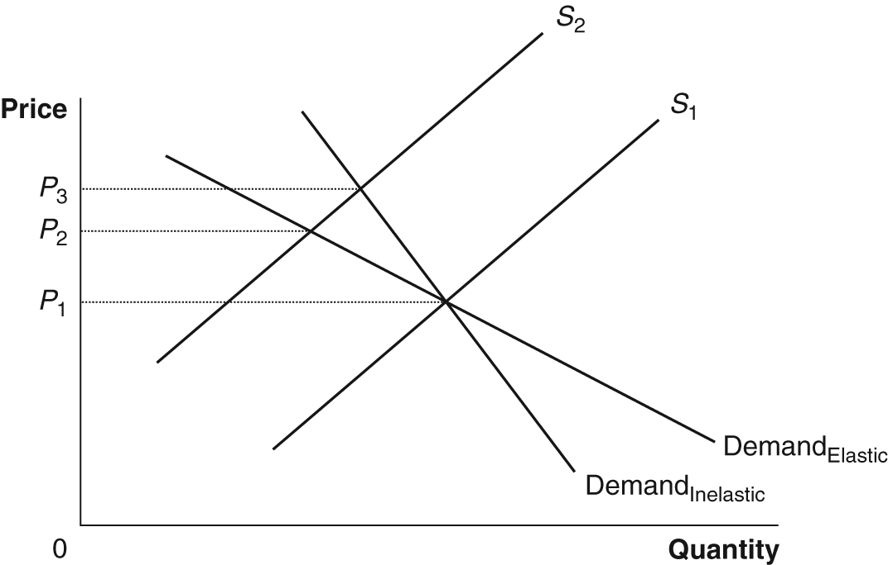

16. The publisher’s analysis is only correct in the unlikely event that demand is perfectly inelastic.

17a. Circulation equals quantity sold.
b. Revenue per copy is the equivalent of price (this probably includes both the price per copy paid by customers and by advertisers).
c. The demand for newspapers is probably price inelastic, so increasing the price will increase total revenue because price increases by a greater percentage than quantity demanded falls.

18. Using the midpoint formula, the percentage change in price was 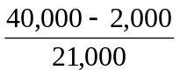 x 100 = 181%. So, the price elasticity of demand = 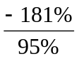 = –1.91.
19a. The gain in revenue is $12 x 500,000 = $6,000,000.

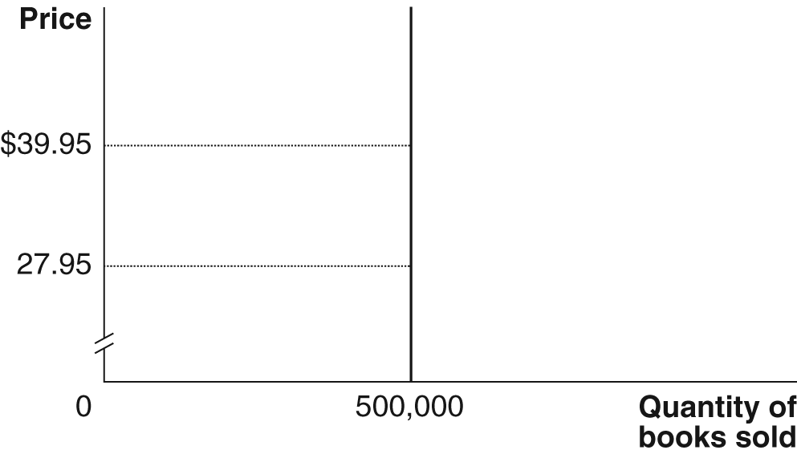

19b. Using the midpoint formula, the percentage change in price =

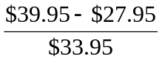 x 100 = 35.3%.

Therefore, the percentage change in quantity demanded = –2 x 35.3% = –70.6%.

So, we have:

–-0.706 = 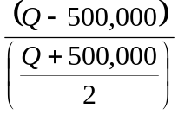; or Q = 239,098.

Revenue before the price change = $27.95 x 500,000 = $13,975,000. Revenue after the price change = $39.95 x 239,098 = $9,551,965. So, the change in revenue is $9,551,965 – 13,975,000 = –$4,423,035.

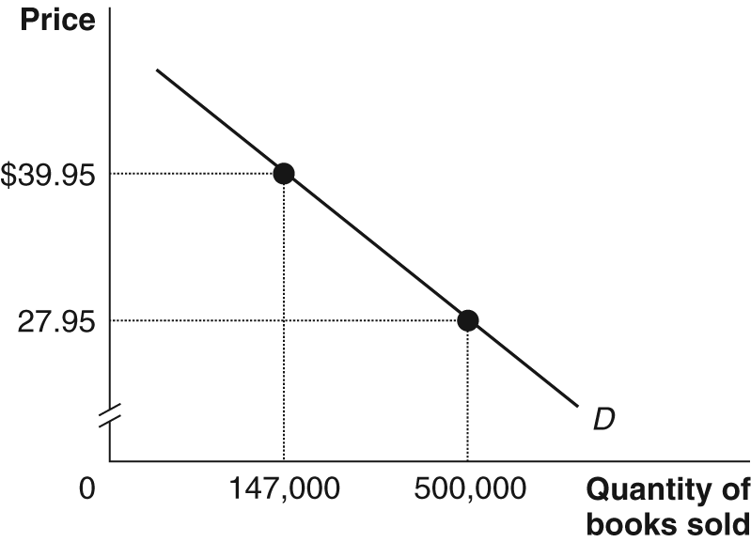

20. His reasoning is correct: The revenue of kumquat producers will fall.

21. We measure the loss of efficiency by the deadweight loss. When demand is elastic, the deadweight loss in the figure is A. When demand in inelastic, the deadweight loss is A + B. Therefore, the loss of economic efficiency from a price ceiling is greater when demand is price inelastic.

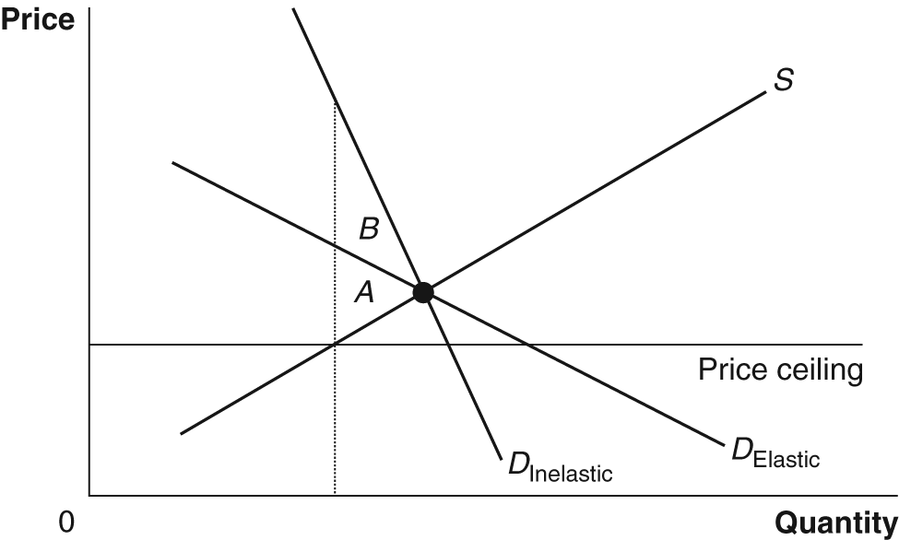

22 a. Lettuce – the percentage change in quantity demanded is much larger for lettuce.
b. Positive. As the price of lettuce rises, the quantity demanded for the other green veggies rises, so they are substitutes.

23a. To find the cross-price elasticity, divide the percentage change in the quantity demanded of buns, ceteris paribus, by the percentage change in the price of hot dogs. At the initial price of buns ($1.20), the quantity demanded rises from 10,000 to 12,000, so this is the change in quantity demanded that should be used.
Percentage change in quantity demanded = 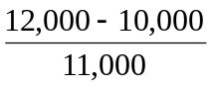= 0.182 or 18.2%.

Percentage change in the price of hot dogs = 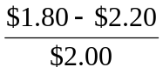= –0.2 or -20%.

The cross-price elasticity = 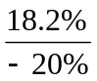= –0.91. As shown by the negative sign, these two goods are complements.

23b. To find the price elasticity of supply divide the percentage change in the quantity of buns supplied by the percentage change in the price of buns while moving along the S curve in the figure. Percentage change in quantity supplied = 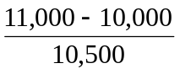= 9.5%. Percentage change in the price of buns = 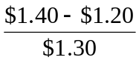= 15.4%. The price elasticity of supply = 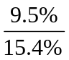= 0.62.

24 a. and c. are substitutes, so the cross-price elasticities will be positive; b. and d. are complements, so the cross-price elasticities will be negative.

25. Because goods with high income elasticities would be increasingly important as incomes rose in Japan and the countries to which it exported.

26. Bread, Pepsi, personal computers, Mercedes Benz automobiles is the most likely order.
27. We can use this information to calculate the price elasticity of demand for tickets to Monday night games, but this isn’t enough information to calculate the price elasticity of demand for White Sox games in general. By cutting the price of Monday night games, the White Sox have probably induced some substitution away from games on other nights, thus we cannot tell what has happened to overall ticket sales.

28a. For the Route 22 Bridge:
Percentage change in quantity demanded = 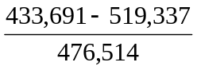= –0.179 or -18%.
Percentage change in price = 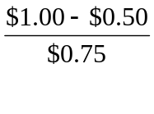= .667 or 66.7%.
Therefore, the price elasticity of demand = 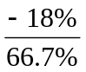= –0.27.

For the Interstate 78 Bridge:
Percentage change in quantity demanded = 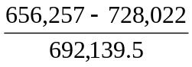= –0.1037 or -10.4%.
Percentage change in price = 66.7%.
Therefore, the price elasticity of demand = 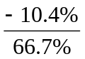= –0.16.
b. Total revenue in November was (519,337 + 728,022) x $0.50 = $623,679.50. In December total revenue increased to (433,691 + 656,257) x $1 = $1,089,948. The increase occurred because the demand at both bridges is price inelastic.

29. To find price elasticity of supply, divide the percentage change in quantity supplied by percentage change in price.
In panel (a), the percentage change in quantity supplied = 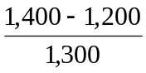 x 100 = 15.4%, and the percentage change in price = 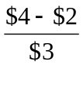 x 100 = 66.7%.
So, the price elasticity of supply = 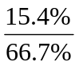= 0.23.
In panel (b), percentage change in quantity supplied = 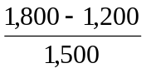 x 100 = 40%,
and the percentage change in price = 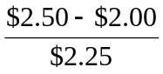 x 100 = 22.2%.
So, the price elasticity of supply = 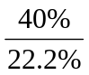= 1.80.

